**Aim:**

To print the “Hello World” program in web page using servlet.

**Program:**

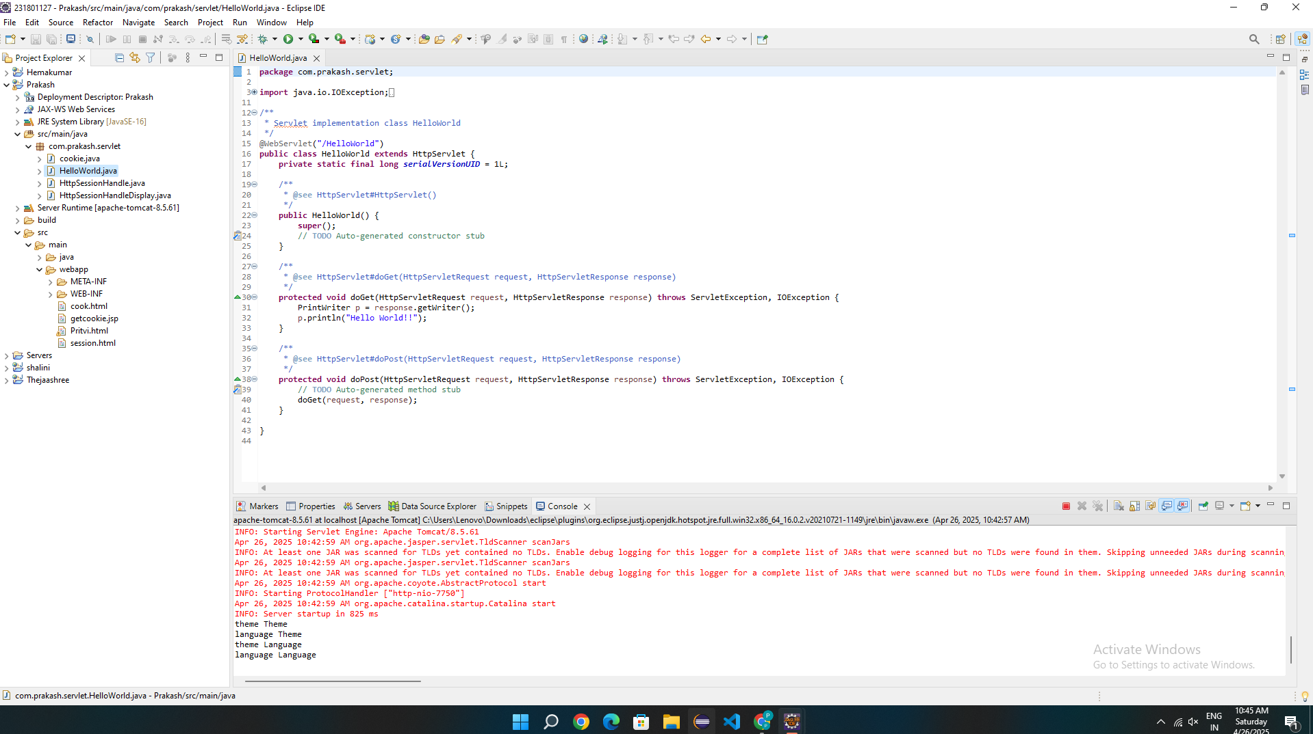

**Output:**

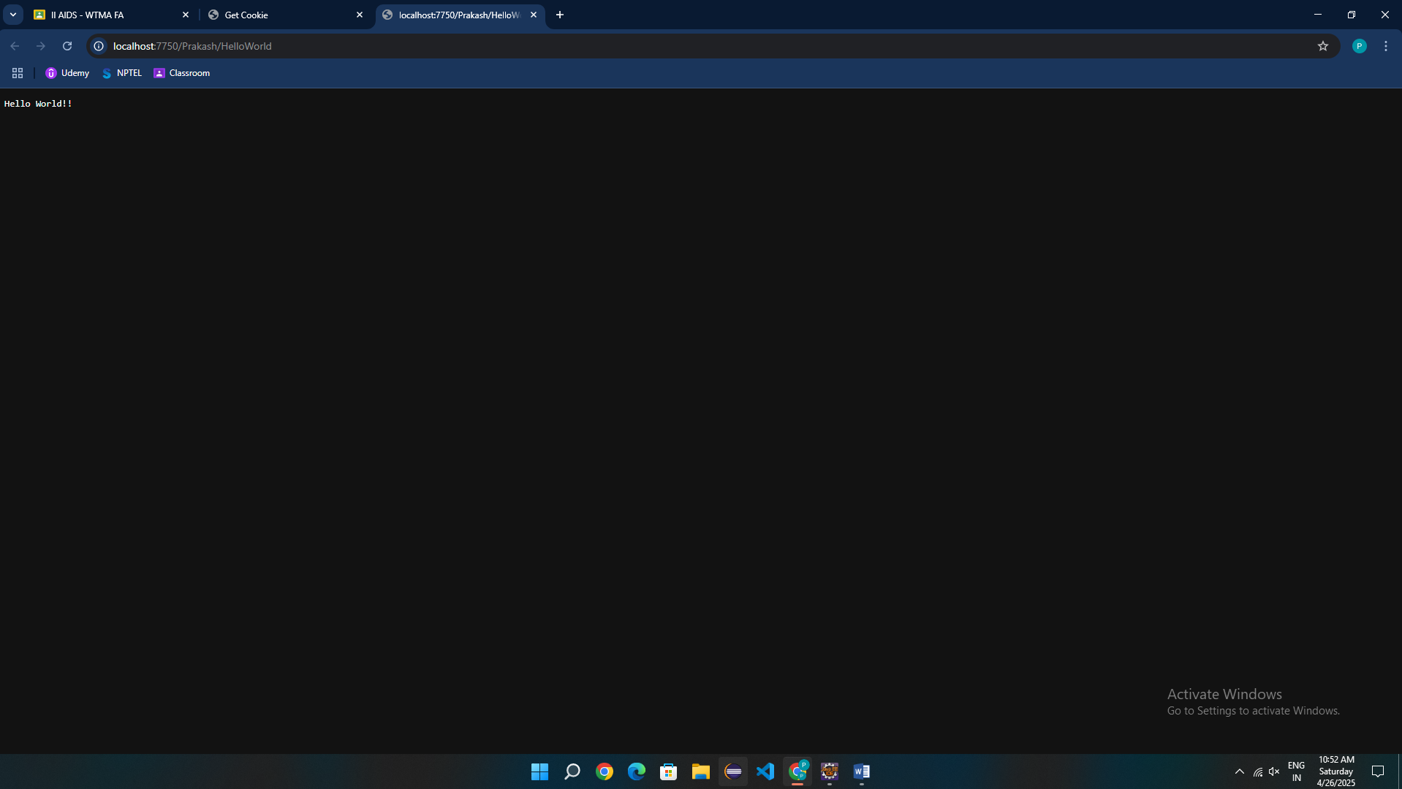

Program:

<!DOCTYPE html>

<html>

<head>

<meta charset=*"ISO-8859-1"*>

<title>Insert title here</title>

</head>

<body>

<center>

<p>Hello World!</p>

</center>

</body>

</html>

Result:

Thus the program to execute “Hello World” using servlet is done successfully.